**Wound edge detection using JavaScript**

Using this JavaScript algorithm (Figure 1) we can detect edge of any wound. This code is compatible with Visual studio.

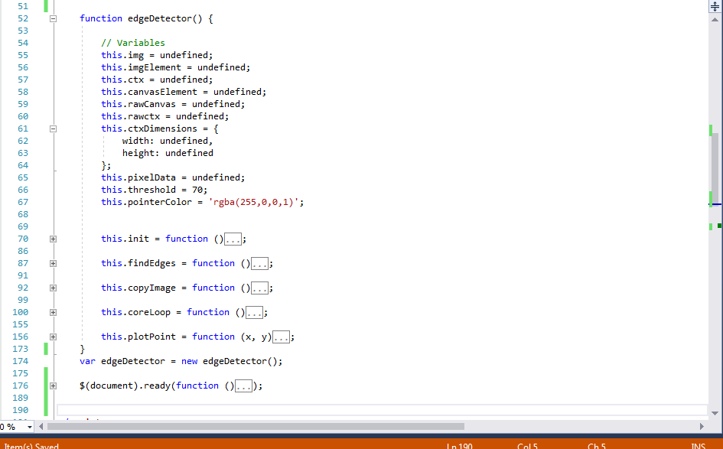

Figure 1: JavaScript Algorithm for wound detection

Detection edge is one of the important parts of our research project. Therefore we can use this algorithm for our web application where user will upload their wound image. After uploading their image we can show the user the exact edge of the wound (Figure 2).

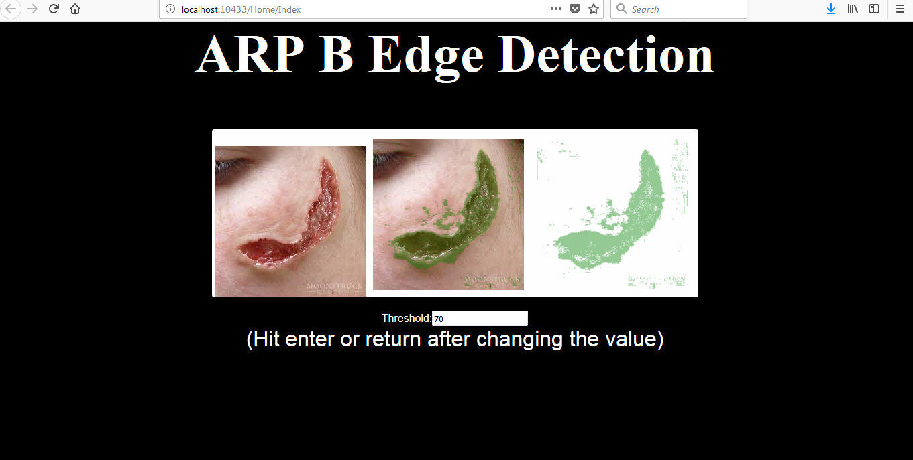

Figure 2: Detect wound edge of the user uploaded image (first one is user uploaded image)

However user can change threshold to make the detection more perfect. There is an input field (Figure 3) where user can change threshold value and press enter to view the change. When the user is done with the threshold value, he can click on a submit button and the system will store uploaded the image with only edge.

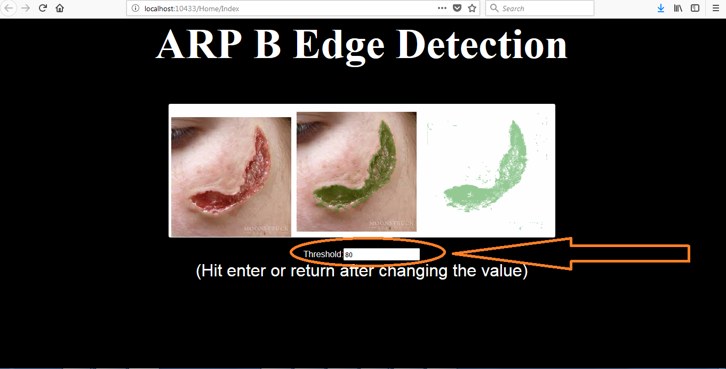

Figure 3: User can change threshold to make the wound edge detection perfect